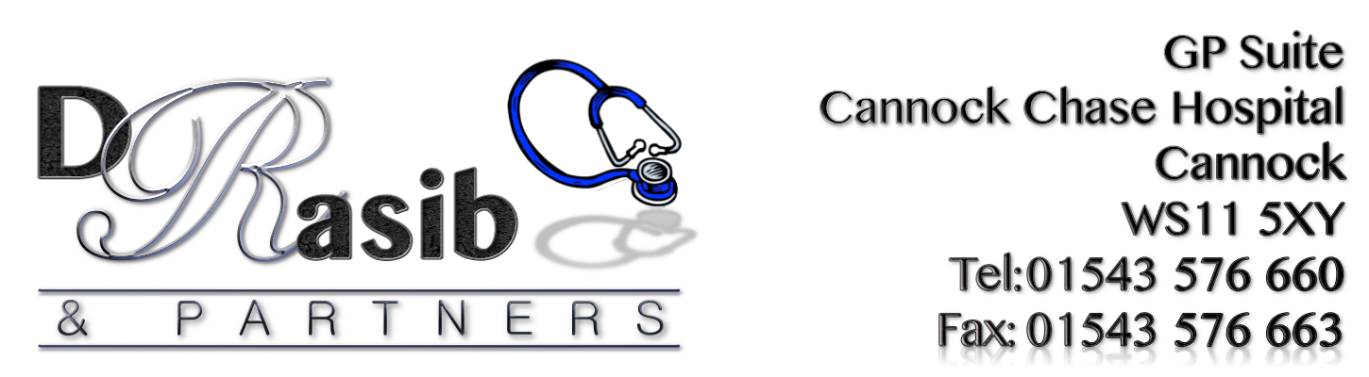

ACTION PLAN-2016

Problems Identified | Action | Who is involved? | Timescales
Preference for booking appointments via phone | The Practice recognizes that telephone contact is the preferred method of communication for patients with regards to contacting the surgery. However, this is adding to the level of telephone congestion that is being experienced by patients and therefore would like to encourage patients to book appointments using alternative methods that are available (patient access) which are just as convenient and result in the same outcome. The practice are therefore intending to advertise online communication method more by advertising it on TV screen in waiting area, through leaflets that will be available for patients in the waiting area and also on the website. We are also offering patient access training sessions for those patients who may need help with using this method and PPG members have offered to help with raising awareness about Patient Access too. Sarah will be doing a display about patient access for the notice board situated in the waiting area and has offered to help with the training too. Sarah has seen the benefits of using patient access so is happy to share her experience with other patients. | GP Partner  Managing Partner  Sarah Giles (PPG)  PPG members  All practice staff | On-going throughout the year
Telephone Access – Getting through to the surgery via telephone has been identified as a major issue | The Practice will continue to source external quotes from telephony companies and also liaise with the Health Informatics/Telephony department within the hospital to see if there are alternate solutions on the current systems. We would however like to encourage patients to use online communication where possible to try and help the practice to improve in this area. | GP Partner  Managing Partner  Sarah Giles (PPG)  PPG members  All practice staff | On-going throughout the year
Lack of awareness about the Practice’s complaint procedure | Further leaflets shall be produced for patients to have access to. The complaints procedure will be advertised further within the waiting area. Details shall also be added to the Practice leaflet and the practice website will be reviewed to try and make the procedure more obvious to patients | Practice Manager | June 2017
Suggestions made on improving surgery | A lot of the suggestions created a common theme and these were ‘More GP appointments’ and ‘Telephone access’ … This has been discussed with the PPG members (9th March 17) and the practice has asked the members to help the practice to find solutions in trying to improve in these 2 areas. Since last year the practice has introduced a further phone line at 8am and another for the whole day, it has been reiterated to all reception staff that all calls MUST be answered within 3 rings, patients are not to be put on hold under any circumstances and a back-up phone has been added for all unanswered calls to be diverted to should the main lines not be answered for whatever reason. The Practice manager holds the backup phone and it has been monitored since being introduced and she can confirm that not many calls have come through to her.  The Practice has been in talks with the hospital and external telephony services to try and come up with solutions but unfortunately so far this has proven to be unsuccessful.  The practice is therefore turning to other solutions and this time it involves encouraging patients to use online communication via patient access.  With regards to lack of appointments, the practice has taken on a Pharmacist Practitioner; he is able to deal with most conditions so again patients are being urged to book with him where possible so this allows the GP to deal with the more complex cases.  The Plan therefore is to raise patient awareness in relation to these 2 areas. | GP Partner  Managing Partner  Sarah Giles (PPG)  PPG members  All practice staff | On-going throughout the year
Patient Buddy Scheme | Aim to advertise this more in the waiting area and PPG members to be involved in this process. Coffee mornings to be arranged to help with advertising both ‘Patient Access’ and ‘Patient Buddy Scheme’.  Our aim will be to get at least 20 patients on the Buddy register in the next 12 months and at least another 5% of patients to be signed up for patient access. | GP Partner  Managing Partner  Sarah Giles (PPG)  PPG members  All practice staff | On-going throughout the year
Becoming a Patient Buddy | The practice and PPG members will continue to raise awareness about this scheme with the aim to get at least 20 buddies in the next 12 months. | GP Partner  Managing Partner  Sarah Giles (PPG)  PPG members  All practice staff | On-going throughout the year

